# 061006T4ICT

**ICT TECHNICIAN LEVEL 6**

**IT/OS/ICT/CR/11/6/A**

**DEVELOP MOBILE APPLICATION**

**Mar. /Apr. 2023**

**Time: 2 hours**



**THE KENYA NATIONAL EXAMINATIONS COUNCIL**

**PRACTICAL ASSESSMENT**

**2 hours**

**INSTRUCTIONS TO CANDIDATE**

*Time allocation:* ***15 minutes*** *for preparation and* ***2 hours*** *for performing tasks.*

*In this practical assessment you are required to perform* ***two*** *tasks.*

You are provided with the following resources to carry out the tasks:

A). Desktop computer or laptop installed with the following software’s

* Windows operating system
* Android Studio
* Android emulator

B) Printer

Figure 1 shows an Android Application APP that allows a user to enter two numbers, adds the Two Numbers and displays the result.

**The sample of the interface is as shown.**

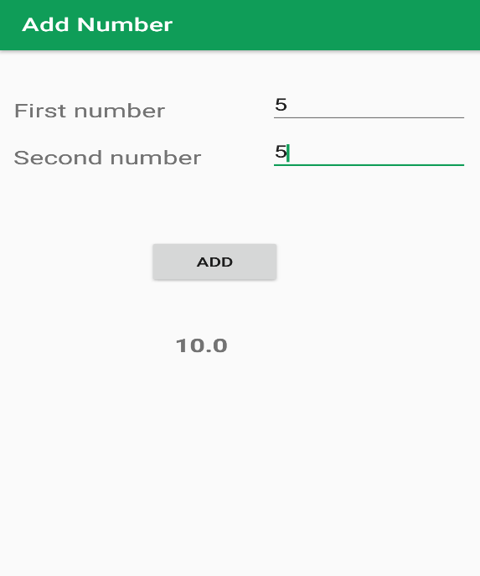

Figure 1: Sample designed app

**Tasks (50Marks)**

1. Design the App using Android studio, Screenshot the codes and print the screenshots.
2. Install the app in emulator, run the App and screenshot the interface of the app and print.

**THIS IS THE LAST PRINTED PAGE**